

SPM – UI Standard Guidelines with CSS  
  
**Standard elements:**  
- Font-Family – sf-pro-text-regular, SF Pro Text Bold (for bold font use font-weight:600 also.)  
- Font-colour: #262626  
- For link colour: #4081c5  
- Basic standard font-size:12px  
- Breadcrumb Title font-size: 16px  
- Icon Sizes: 32*32, 24*24, 18*18, 16*16  
- Standard theme blue colour code: #4081c5  
- Body background colour: #F0F2F5  
  
  
  
Basic Instruction for maintain the CSS related code structure:  
  
- For the form related CSS you can use po-form.css file and add your custom styles  
- For custom global styles you can use po-main.css  
- For grids and register pages you can use po-register.css & DemandBacklogStyle.css   
- For calendar control regarding styles you can use popcalendar.css  
  
  
  
Some other guidelines:  
  
- Every popup should come with the dimmer and place into the centre of the screen  
- New tool-tip should implement  
- Icons should have opacity of 0.6  
- For breadcrumb you can take reference from workspace page or standard code. The styles are commonly written so just need to place and manage the code structure over the particular page  
- If you are using any max length of content over grid or form, kindly add truncation over the same and show the rest of the content over the tooltip  
- Kindly mention your comment properly in your development so that it will help others.  
- If we are adding any new style or CSS then needs to add over relative page  
- Avoid inline-style placement over the aspx or ascx pages  
- Try to use common classes – it will help to avoid repetition of code and impacts  
  
  
  
  
  
  
  
  
**Popup:**  
There are 4 kind of popups – **Modal, Nonmodal, Lightbox, Nonlight box**  
  
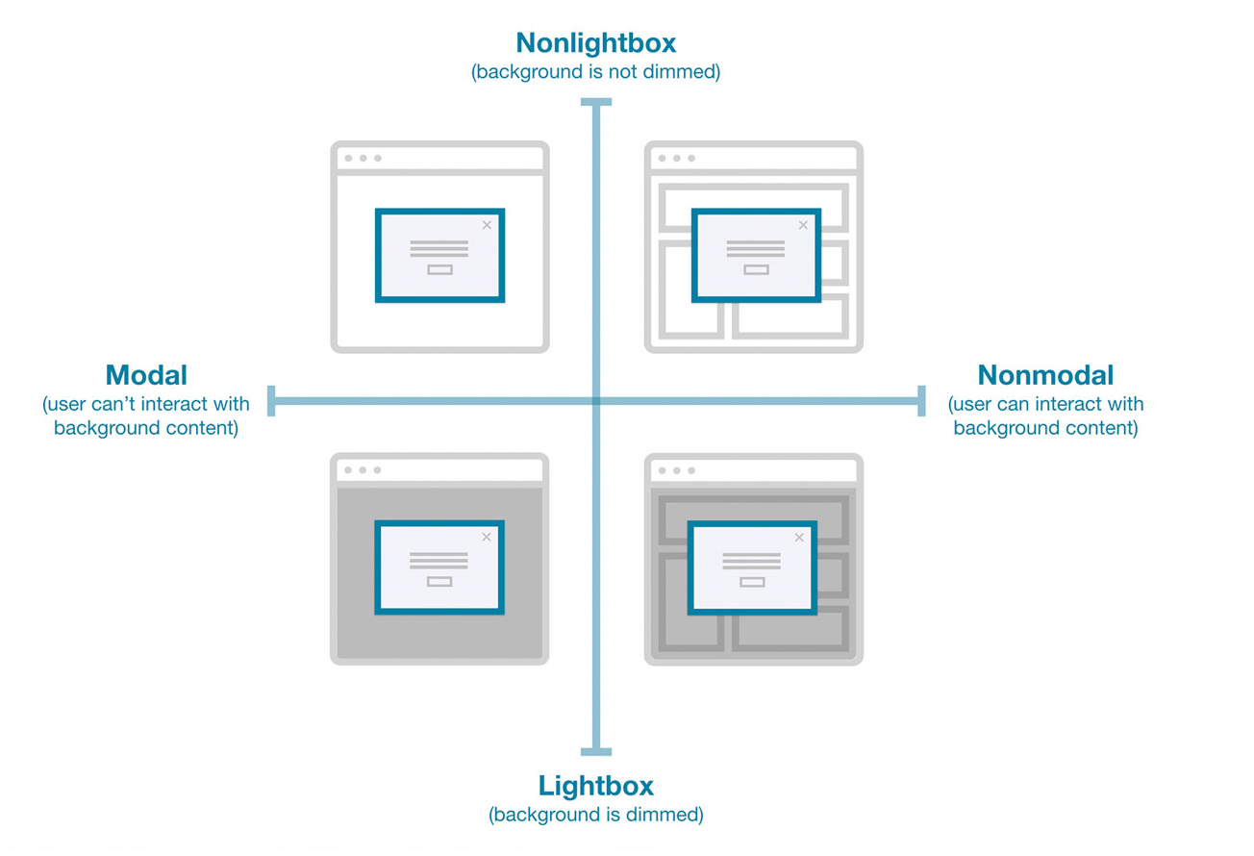  
  
  
- The large popups should always have the **background dimmer**, overlay colour: #00000080  
  
- Close icon should come on the **right side**  
- There will be no action icons on popup’s, the icons needs **to change into the button** and that button always place in the **right bottom corner** with the standard padding.  
  
- Fotter where the button will place, needs to come with **border-top**  
- For Header of the popup, need to use title and sub details (if required, with the less size)  
  
- The background colour of the popup will **white only**.  
  
  
  
  
  
  
  
  
 **Buttons:**  
- Buttons can come anywhere in the application where the action performs and buttons name can be anything like: **Cancel, Save, Apply, ok, View, Approve, Delete, Clear, etc.**- Colours of the buttons: **#4081C5, #fffff, #ef6262**  
- Padding: 6px 16px;  
  
- font-size:12px  
  
- Font colour: **#fff** (On cancel button colour will change into **#262626**)  
  
  
  
  
  
**Icons:**  
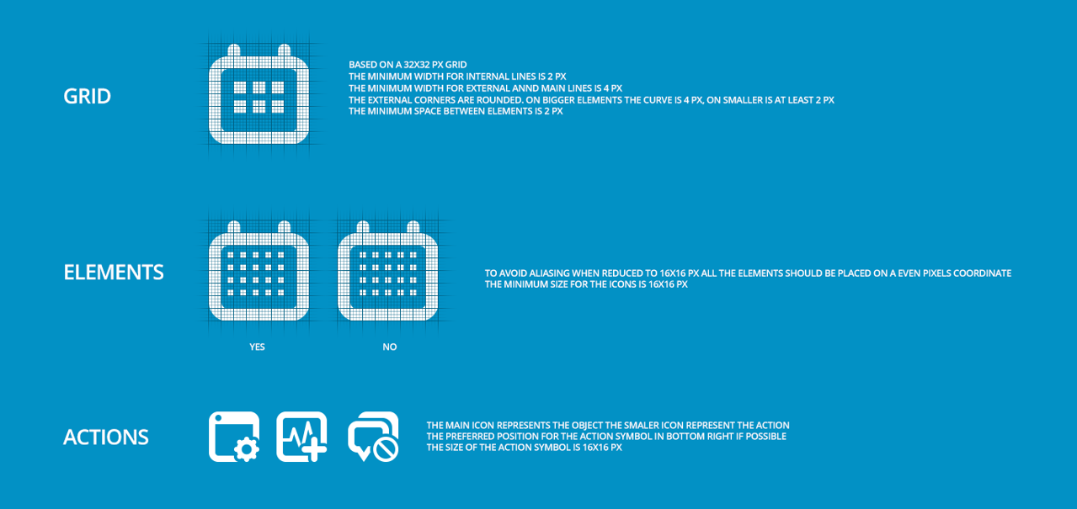  
  
The icons can be place anywhere but the size will be differed from each other as per the requirement.   
  
You can find all the icons in **Image & Images folder of the repository**, and standard coloured icons are in **newico** folder with the standard size of **128*128** (so that pixels will maintain over high resolution). You can manage the width & height as per your choice.  
  
  
  
**Tooltip:**  
For tooltip there is standard **CSS & JS** file, which will help to manage the default hover tooltip into the new one, you just need to add the class defined for the same.  
  
<script src="js/Tooltip/Tooltip.js" type="text/javascript"></script>  
<link href="PO_UI/tooltip.css" type="text/css" rel="stylesheet" />  
  
Tooltip background is **#5c5b5d** & colour **#fff**  
  
  
**Nav Menu:**  
Icon colour - white  
Selected Menu - Border will come (border-left: 2px solid #fff;)  
Used font - sf-pro-text-regular + Size: 12px  
Height of menu nav – height:50px  
  
  


Navigation menu is the major part of the application, from these menus you can access the main module landing pages like: Home, Dashboard, Portfolio, Strategy, Program, Configuration or setting. These menus will be managed through the menu setup area in Application configuration. The basic standard styles which we are using are mentioned above.

**Top Header Menu:**

The top header menu contains several elements like:  
  
- Breadcrumb or Title of the page  
- On the right corner User Profile option   
- Other functionality like: Help, Notification, Search, COS, Global Create  
  
  
  
 **Cards (Over landing pages):**We used card structure on our landing page to show and customize the related information. Basically, we have two rows for the cards, one is for Pinned and other is Recent.  
  
Card contains multiple details and functionality:  
  
- Image  
- Title  
- Team functionality  
- More option over three dot menu  
- Details in content area  
- Pinned & unpinned option  
- Whole card perform the redirection towards workspace  
  
Style Elements of the Card:  
  
- Background: #ffff  
- Box-shadow is on-hover  
- colour: #262626  
- Title font-size: 14px + Font-Weight: 600  
- Height auto adjustable – Set min height  
  
  
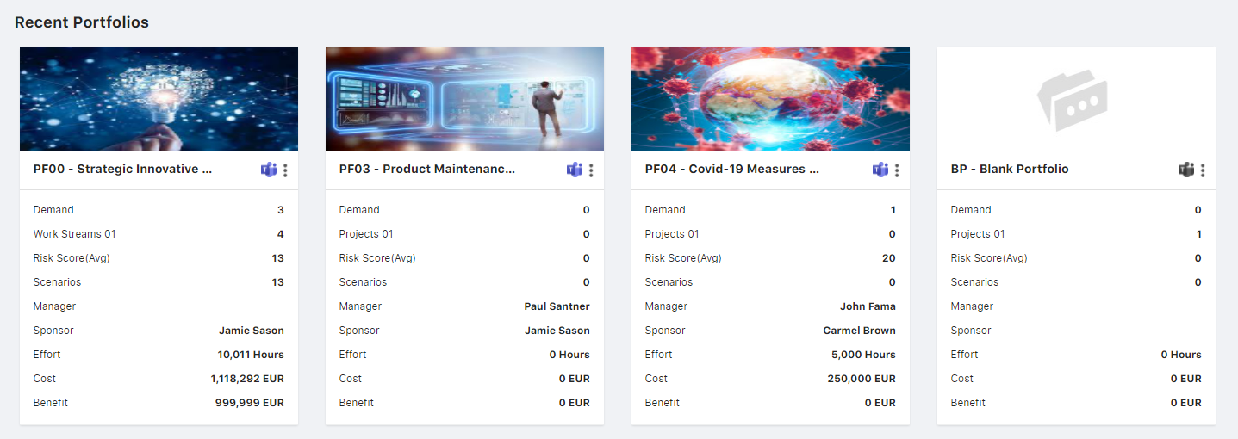

**Forms:**If we talk about forms, there is no fixed structure for the same, but as per the application standard we can follow few guidelines which helps to manage the structure of the form layout.  
  
Majorly two kind of forms you can find over the application, 1 with tabs & other without.  
  
  
Standard guidelines for the form:  
  
- Section Heading: Every form have section heading where we need to implement the predefined **class: HeaderLabel**- Label Font Size: **12px**- Input, Select, text-area or text-field: **border: 1px solid #d9d9d9; (rest of the css already implemented over the po-form.css)**- You can align the multiple fields in a single row as per the provided space over the form.  
  
- There will be no action icon over the page, If we are using cancel, delete, create, apply and save all will be covert into the buttons and manage over form footer area. (Button related guidelines are mentioned above of the document)  
  
- If scroll required because max data then the scroll will be added on the form container not over the page body  
Tab UI Sample  
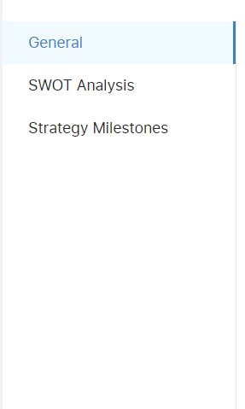

Form UI Sample  
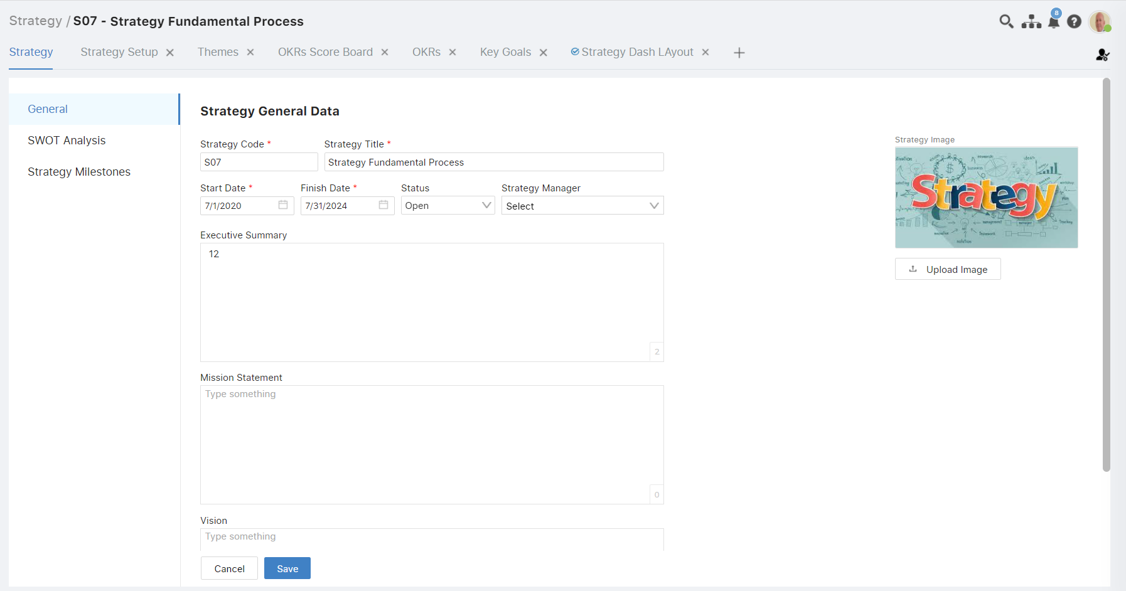  
  
  
For the reference, you can check over Strategy, Portfolio, Demand detail or create page  
  
 **Three Dot menu:**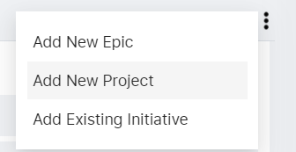As per the above screenshot, you need to manage the three-dot menu design accordingly. Basically, if we need to add any action option then we need to put inside this same container.   
  
**CSS: -**  
- Height: auto (as per the count of inner content)  
- Float: Right  
- Padding:10px  
- background: #fff  
- min-width:200px  
- box-shadow: 0px 9px 28px 8px rgb(0 0 0 / 5%), 0px 6px 16px rgb(0 0 0 / 8%), 0px 3px 6px -4px rgb(0 0 0 / 12%)  
- On Hover of list – background: #f5f5f5 with 100% width

**Grids:**  
  
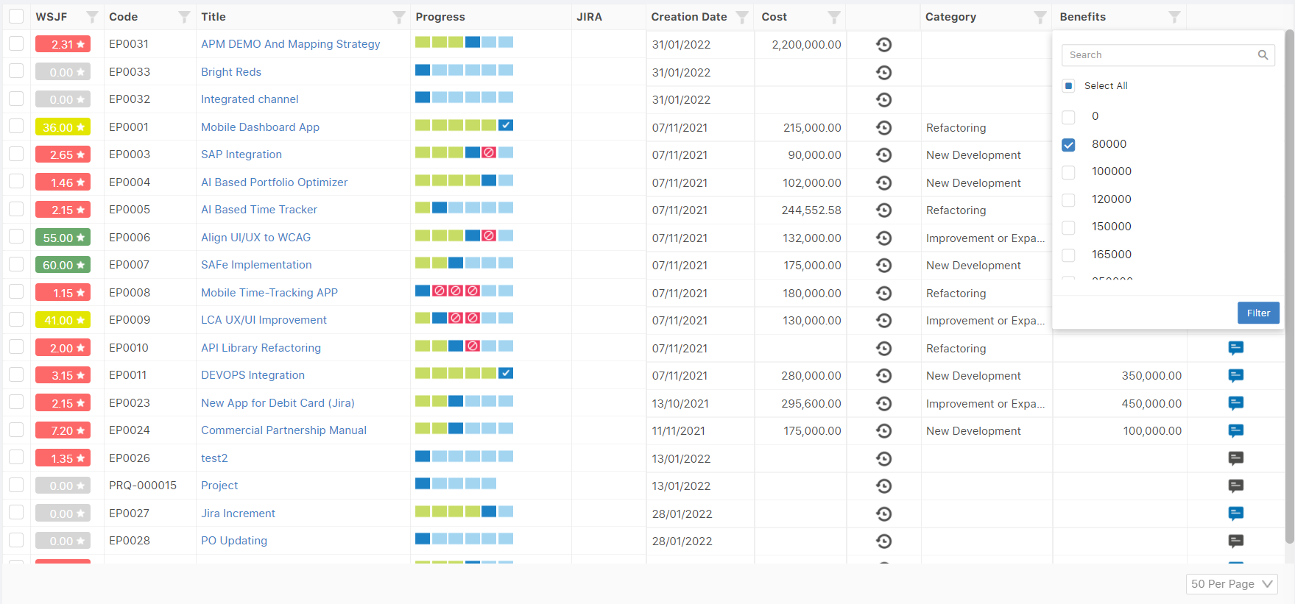  
  
As per the current standard guidelines, we are using dev-express grid with multiple functionalities. So, we need to follow the standard of the UI implementation over the same or in future developments.  
  
Here you find some basic guidelines which helps you to manage the grid structure and maintain the consistency with the finalized development.

**Rules for alignment:**Cells:

- If it's alphanumeric alignment should be in the left

- If it's numeric or date or currency alignment should be in the right

- If it's icon or image alignment should be in the centre

Every single column can be filtered out through the filter option which is a place along with the column header, which represents through the filter icon.

The child grid size is compact compare to the above parent row.

Grid Header:  
  
- Background: #FAFAFA  
- Cursor: Pointer (as header contains sorting option)  
- Font-family: ‘SF Pro Text Bold’  
- Font-Weight: 600  
- Letter Spacing: 0px  
- Text-transform: Capitalize  
- Justify-content: Centre  
- Flex-direction: column  
- Line-Height: 15px  
- Padding-left: 5px  
- Padding-right: 5px  
- Font-size: 12px  
- border-left & right: 1px solid #efefef  
- colour: #4c4c4c  
  
[ Above style will work over the cells to except font-family and weight for that you can use font-weight: 400 & Font-family: sf-pro-text-regular]  
  
  
Grid contains anything like: Code, title, WSJF, Jira column, target date, creation date, history, benefits message or comment, etc.  
  
For better reference, you can visit the Demand listing page (DemandBacklog.aspx)  
  
  
Widget Grid:  
  
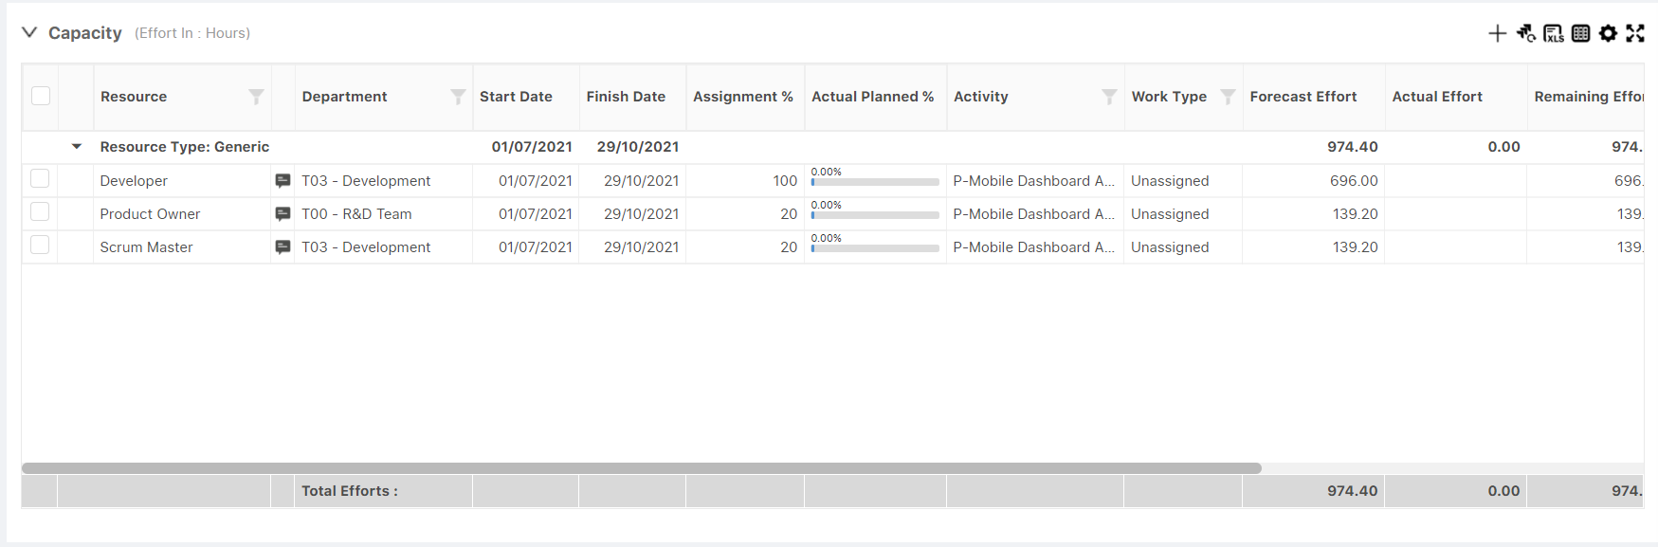  
  
The style related guidelines are same like above just have difference over the widget header and below footer.